Recalculation of the model N-LES
Published in Danish 2003.
Kristian Kristensen, Uffe Jørgensen, UNIVERSITY OF AARHUS, Faculty of Agricultural Sciences, Dept. of Agroecology and Environment, Blichers Allé 20, P.O. BOX 50, DK-8830 Tjele, Denmark
Ruth Grant, UNIVERSITY OF AARHUS, National Environmental Research Institute.

Introduction

The N-LES₃ model is the third version of an empirical model to calculate N leaching (Simmelsgaard et al., 2000). Leaching in the model is based on events in the year of leaching and on the part of the rotation that is described by the precrop and the previous five years’ nitrogen applications. The model has been developed using data from both the Faculty of Agricultural Sciences (DJF) and the National Environmental Research Institute (NERI). The following shows the results of the recalculated N-LES₃ model. The recalculation is based on the latest knowledge on water balance calculations.

Data sources

The data used in N-LES₁ have been supplied by additional data from the watersheds monitored, i.e. data from the years 1999/2000 and 2000/01 in addition to new data from measuring series on drainage water. Data from other experiments at DJF not previously used have also been included. In total 1299 observations are included in the estimation of the model parameters (in the N-LES₁ and N-LES₂ models, the numbers of observations were, respectively, 598 and 596).

The more recent data show leaching levels and ranges that are generally somewhat lower than those previously used. Average leaching and the range of leaching used in N-LES₂ were thus, respectively, 74 and 62 kg N ha⁻¹, while the averages in the more recent version are, respectively, 64 and 57 kg N ha⁻¹. The smallest and largest leaching levels recorded are unchanged at 0 and 446 kg N ha⁻¹.

Calculation of drainage and thus leaching has been changed compared with previous versions, as updated rainfall corrections and evaporation using the Makkink formula and crop coefficients (K_{c}) that may exceed the value 1 (Plauborg et al., 2002) have been used.

The amount of nitrogen (N) fixed by a main crop, and any catch crop, have for the NERI data been calculated using the Danish farm planning program ‘Bedriftsløsningen’, while DJF data have been calculated according to Høgh-Jensen et al. (2004). The latter requires information on the dry matter content of harvested legumes, which is usually included in the experiments at DJF, but not in the NERI data from the monitoring programme (LOOP). A comparison of the two methods shows that at typical clover levels, the same fixation level is obtained, whilst at atypical clover percentages the most precise estimate is achieved using the method of Høgh-Jensen et al. (2004).

Choice of model type and explanatory parameters

For the recalculation of N-LES the same basic structure has been used as previously (Simmelsgaard et al., 2000). This means that the model comprises both additive parameters and multiplicative parameters. The model has, however, been modified in a number of areas on the basis of new knowledge and discussions with users of the model:

- The effect of crop has been changed from a multiplicative to an additive effect. The precrop has been included as an additive effect in order to describe their effect on variation in residual N levels in the soil, and the number of groupings of crops and precrops has been reduced to reduce the number of parameters.

- A technology effect has been introduced, which describes any significant development in leaching over time that the model cannot explain from changes to crop rotation, fertilization, etc.
- All additive effects that directly or indirectly describe added or removed N have now been summed before they are raised to a power. This makes the effect of a specific source of N dependent on how much is added/removed by the other sources. For example, the effect of 1 kg spring-applied plant-available N will be larger if the N level is 200 kg N than if it is 150 kg N. If the sum of the additive effects describing added or removed N becomes negative, it is set at a very small value and some of it is additionally transferred to part of the additive effects that are not raised to a power. This is done in order to ensure a slope on the N response curve at low N levels.
- An effect of previous year’s drainage has been introduced in order to incorporate the leachable N that may remain in the soil – particularly in dry years – from previous years.
- The N level has been calculated as the average amount of N added in the five years of leaching previous to the actual year of leaching. When information about the five previous years is not available, average N values from the first five years with recordings have been used.
- The newest methods for calculating water drainage and N fixation have been adopted (Plauborg et al., 2002; Høgh-Jensen et al, 2004).
- Minor changes to the structure for random effects have also been made.

In connection with the setup of the model, several explanatory variables were investigated but not included. These were the effects of spring and autumn-applied organic N in animal manure as separate parameters (they are included in the N level) and the land use and precrop history of the field (three types of crop rotations and three levels of manure applications 6-30 years prior to the year of leaching). The effects of organic N in animal manure were small and not significant and were therefore omitted. The effects of land use and precrop history were both significant but difficult to explain. As the information on land use and particularly precrop history was uncertain, these effects were also omitted from the N-LES₃ model. It is, however, clear that it is necessary to continue the work to describe and quantify the effect of field history.

Results: N-LES₃ model

Tables 1 and 2 show the parameter estimates for the fixed effects of the model together with an approximate standard error. With the chosen effects and parameter estimates, the level of leaching Y can be predicted for certain values of the explanatory variables using the equation:

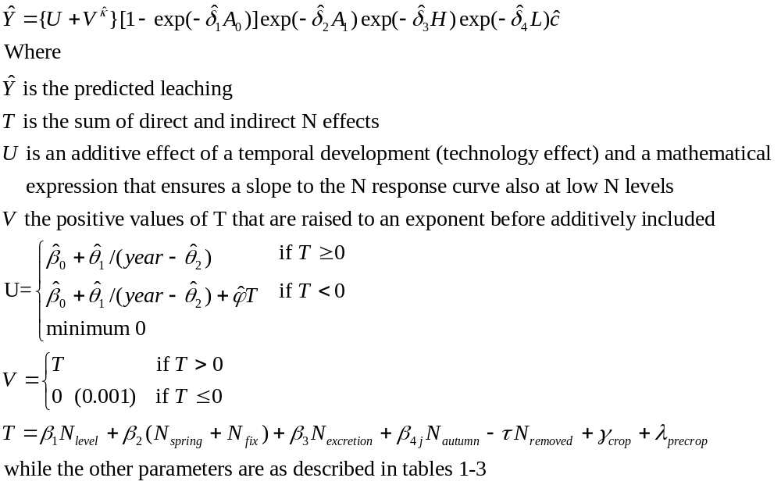
Table 1. Estimates and standard errors of additive effects

Parameter | Effect | Parameter estimate | Approx. standard error
Κ | Exponent | 1.2 | -
β₀ | Intercept | 59.6 | 24.6
θ₁ | Technology effect | 2455 | 646
θ₂ | Technology effect | 1962.2 | 2.6
β₁ | N level | 0.3255 | 0.0515
β₂ | N spring | 0.2528 | 0.0423
β₃ | N excretion | 0.3760 | 0.1226
β_{4s} | N autumn, sandy soil | 1.0749 | 0.3470
β_{4l} | N autumn, clayey soil | 0.3539 | 0.1161
Τ | N removed | 0.1936 | 0.0471
Φ | Proportion of negative N used in U | 0.5466 | 0.0950
 | Crop groups¹
γ₁ | Grass for seed +Grass | -165.7 | 26.3
γ₂ | Cereal/grass undersown +Cereal/catch crop or winter rape | -98.6 | 15.2
γ₃ | Grass-fallow/winter cereal +Turnips +Spring rape | -42.0 | 8.5
γ₄ | Cereal/winter cereal | -7.6 | 7.6
γ₅ | Cereal/bare soil +Peas +Winter rape/winter cereal | 0 | -
γ₆ | Potatoes +Maize | +28.8 | 16.6
 | Precrop groups¹
λ₁ | 2nd and 3rd year grass | +34.7 | 11.0
λ₂ | Grass for seed +1st yr grass +Maize +Cereal/catch crop or winter rape +Grass-fallow/winter cereal +Rape | +14.2 | 5.8
λ₃ | Cereal/grass undersown +Cereal/winter cereal +Cereal/bare soil +Turnips +Peas | 0 | -
λ₄ | Potatoes | -38.5 | 14.8
¹Crop and precrop effects have been calculated relative to the group containing cereal followed by bare soil (this group by definition has the value 0).

Table 1 shows the additive effects that comprise the effect of added N, N level, N-spring, N-autumn and N-excretion and precrop effects.

Intercept can be interpreeted as the leaching of N from a cereal crop field followed by bare soil with a cereal/bare soil precrop and with a clay and organic matter content of 0%, where no N has been added and where leaching has been, respectively, infinitely large and zero in the current and previous leaching years.

Year is the year when the leaching year starts. Year 2001 is, for example, the leaching year that starts in the summer 2001 and finishes after the winter 2002. The technology effect explains the fall in leaching taking place over the period that cannot be explained by the input variables. This could be the effect of new varieties, changes to soil management or crop protection. Changes in temperature and increasing CO₂ levels can, however, also have an effect. The technology effect is largest in the 1970s and reduces over time. As the technology effect cannot in any sensible way be extrapolated to coming years, it is recommended that in the future aplication of the model the year 2001 is used – the last year of the data material.

N-level: Has been calculated as the average addition of N in the five years of leaching prior to the actual year of leaching (where no information on the five previous years is available, average N levels from the first five years of data are used). Added N comprises the sum of total-N in artificial fertilizer, animal manure, deposition from animals on grass and biological N fixation.

N-spring: Is the amount of added mineral N in the period between 15 February and 1 September.

N-fixation: Is the amount of N fixed by crops grown in the year of leaching.

N-excretion: Is the total amount of N deposited on the field during grazing.

N-autumn: Is the autumn-applied artificial fertilizer and winter-applied (1.9 – 15.2) ammonium-N in animal manure.

N-removed: Is the amount of N removed with the crop in the actual leaching year. The calculation is based on the amount of dry matter removed (including straw) and its N content. Standard values will be used where there are no recordings.

Crop effect: The effect of a crop group is estimated as being either larger or smaller than group 5 (cereal/bare soil, peas or winter rape/winter cereal). It appears that group 1 has an indirect N effect of -165.7. Group 1 therefore – all other things being equal – produces the least leaching. The largest leaching levels are achieved with crops in group 6.

Precrop effect: The effect of a precrop group is estimated as being either larger or smaller than group 3 (Cereal/grass undersown, Cereal/winter cereal, Cereal/bare soil, Turnips or Peas).

Table 2 shows the multiplicative effects that describes effect of soil types and drainages.

Table 2 Estimates and standard errors of multiplicative effects

Parameter | Effect | Parameter estimate | Approx. standard error
δ₁ | Drainage in leaching year | 0.001502 | 0.000247
δ₂ | Drainage in previous leaching year | 0.000554 | 0.000090
δ₃ | Organic matter content | 0.1064 | 0.0226
δ₄ | Clay content | 0.0325 | 0.0065

Drainage in current leaching year: The drainage is calculated using a model. It has a very strong effect on leaching. At large drainage events (where leaching is not limited), a multiplication factor of 1 is used. At drainage of 1000 mm, a factor of 0.777 is used, while the factor reduces with lower levels of leaching and is, for example, 0.015 at 10 mm drainage.

Drainage in previous leaching year: The drainage is calculated using a model. It has a smaller effect on leaching. At low drainage events (where leaching the previous year was virtually non-existent) the factor is close to 1 and becomes smaller with increasing levels of drainage the previous year. At a drainage the previous year of 1000 mm, the factor is 0.575.

Soil type: Is characterised by percentage organic matter and clay in the topsoil. Leaching reduces with increasing soil organic matter content and clay content. An increase in soil organic matter content from 2% to 4% thus reduces leaching by approx. 21%. An increase in soil clay content from 6% to 10% correspondingly reduces leaching by approximately 13%.

Random effects and coefficient of determination

Table 3 shows the contribution to the variability of ln(Y) for each of the random effects, the coefficient of determination (R²) and the standard deviation.

Table 3. Number of observations, variance of random effects, correction factor and coefficient of determination and standard deviation on the deviation between recorded and predicted leaching

Parameter | Effect | Parameter estimate
N | Number observations | 1299
σ_{s}² | ¹Field/treatment | 0.0953
σ_{y}² | Year | 0.0112
σ₁² | Residuals, DJF | 0.2201
σ₂² | Residuals, NERI without grazing animals | 0.4346
σ₃² | Residuals, NERI with grazing animals | 0.6498
C | Correction for skewness | 1.2453
R² | Coefficient of determination | 0.531
Std | ²Standard deviation, kg N ha⁻¹ yr⁻¹ | 35.4
¹Field or plot, recording station for NERI data
²Calculated on the difference between recorded and predicted leaching

Residual variance: The residual variance on ln(Y) corresponds to a coefficient of variation on leaching of approx. 50-80%. If random effects are included, the coefficient of variation is 60-90%. Residual variance includes several components. The most important are: 1) uncertainty relating to concentrations in water in suction cups due to, e.g., soil variation, variation in the application of fertilizer, etc., 2) uncertainty in the explanatory variables such as applied fertilizer, harvest yields, etc, and 3) the inability of the model to explain all the details. The coefficient of variation therefore depends on the observation type, as many relations must necessarily be more uncertain when the explanatory variables are based on interviews rather than formal experiments, likewise the uncertainty relating to application of fertilizer will be larger when some of this originates from grazing animals.

Correction for skewness: In order to predict the same average as measured backtransformed predicted values for leaching are multiplied by 1.245. The criterion for the correction factor is that recorded and predicted average leaching values should become equal.

Coefficient of determination (R²): is somewhat lower than earlier, which is due, among other things, to the number of observations increasing steeply from 596 to 1299 and the new observations being less extreme than earlier data.

Standard deviation (Std): describes the extent of the average deviation between recorded and predicted leaching. A value of 35.4 corresponds to approx. 55% of the average leaching in the data. Although this is lower than previously, it is still large. Even with the best of models, the standard deviation can, however, not be less than the standard deviation on recorded leaching. It is associated with a large level of uncertainty and in some experiments with measurements in replicated plots in the same field it has been found to vary between approx. 1-200% with an average value of around 40%. On this background the model is deemed to give a good description of the utilized data.

Model verification

Work is currently under way to describe the uncertainty associated with the use of the model. This description is intended to contain the following three parts (This work is now published by Larsen and Kristensen, 2007):

- A validation of the model by successively omitting sections of data and reestimating the parameters on the remaining observations in order to use those new estimates to predict the leaching on the data omitted.
- A description of the uncertainty on a prediction of leaching at field level with given explanatory variables, including the uncertainty in the prediction of leaching for a property with several fields.
- A method that shows the uncertainty on the effect of a change in strategy. This could gor instance be the effect of a change in the amount of applied fertilizer or a change in the crop rotation.

The following shows a number of tables and figures that can be used for a preliminary validation of the model.

Table 4 shows the measured and predicted leaching for each locality and/or experiment. A good agreement between recorded and modelled leaching can be seen. However, in a few series estimates deviate considerably from measured leaching. This could be due to the effect of variables that the model does not take account of. The experiments may, for example, have taken place in a period with cold autumns and winters, which reduces mineralization in the leaching period.

Table 4. Measured and predicted leaching for each locality or experiment. Only fixed effects have been used to predict the leaching (i.e. without including the random effect of the individual field or year)

Locality/experiment | Year | No. obs. | Measured  kg N/ha |  |  | Predicted  kg N/ha
 |  |  | Avg. | Min | Max | Avg. | Min | Max
Loop1 | 91-00 | 57 | 33 | 0 | 125 | 25 | 0 | 69
Loop2 | 91-00 | 57 | 113 | 11 | 238 | 100 | 14 | 240
Loop3 | 91-00 | 44 | 62 | 1 | 235 | 51 | 9 | 162
Loop4 | 91-00 | 59 | 58 | 0 | 178 | 59 | 0 | 150
Loop5 | 91-97 | 47 | 114 | 0 | 275 | 110 | 0 | 306
Loop6 | 91-00 | 74 | 127 | 10 | 423 | 109 | 11 | 333
Drain water | 71-01 | 94 | 64 | 5 | 197 | 68 | 16 | 178
Grid | 88-93 | 89 | 60 | 0 | 203 | 56 | 12 | 172
Catch crop | 87-91 | 40 | 48 | 7 | 100 | 74 | 33 | 178
Grass plough-in | 89-94 | 45 | 65 | 2 | 127 | 92 | 16 | 156
Increasing N | 73-90 | 111 | 41 | 2 | 210 | 50 | 10 | 138
Spring barley, catch crop 2xN | 87-91 | 42 | 55 | 13 | 127 | 51 | 16 | 152
Spring barley, catch crop 4xN | 93-96 | 32 | 57 | 19 | 116 | 52 | 13 | 110
Crop rotation, organic matter | 89-92 | 66 | 54 | 5 | 138 | 62 | 24 | 163
Crop rotation, 3xN | 89-92 | 42 | 49 | 9 | 138 | 62 | 28 | 152
Roughage rotation | 89-92 | 32 | 38 | 12 | 82 | 51 | 28 | 78
Organic rotation | 96-00 | 164 | 59 | 7 | 283 | 50 | 9 | 241
Organic livestock rotation | 94-97 | 96 | 39 | 0 | 149 | 46 | 2 | 157
Grass and clover, residual effect | 97-99 | 54 | 32 | 5 | 95 | 35 | 19 | 60
TPII | 87-89 | 18 | 97 | 21 | 270 | 105 | 38 | 276
Low input | 97-00 | 36 | 47 | 14 | 153 | 31 | 15 | 102
Table 5 likewise shows measured and estimated leaching for each of the 16 crop groups. The largest deviations are with Grass/winter cereal and Spring rapeseed/winter cereal.

Table 5. Measured and predicted leaching divided for each combination of summer/winter crop. Only fixed effects have been used to predict the leaching (i.e. not including the random effect of the individual field or year).

Crop  summer/winter | No. obs. | Measured kg N/ha |  |  | Calculated kg N/ha
Crop  summer/winter | No. obs. | Avg. | Min | Max | Avg. | Min | Max
Seed grass/grass | 19 | 20 | 0 | 70 | 26 | 8 | 41
1st yr grass/grass | 92 | 42 | 1 | 227 | 36 | 4 | 123
2nd yr grass/grass | 72 | 62 | 0 | 275 | 51 | 4 | 169
Spring barley w. undersown grass | 315 | 42 | 1 | 275 | 38 | 2 | 178
Grass/winter cereal | 47 | 72 | 6 | 246 | 80 | 17 | 268
Fodder beet/bare soil | 58 | 65 | 2 | 189 | 64 | 4 | 165
Industrial beet/bare soil | 30 | 32 | 0 | 135 | 37 | 0 | 101
Potatoes/bare soil | 19 | 115 | 0 | 256 | 127 | 0 | 240
Cereal/winter cereal | 116 | 67 | 0 | 274 | 72 | 0 | 178
Cereal/catch crop, rapeseed | 45 | 44 | 10 | 242 | 41 | 14 | 150
Cereal/bare soil | 409 | 72 | 0 | 325 | 77 | 0 | 333
Spring rapeseed/winter cereal | 12 | 103 | 20 | 242 | 75 | 20 | 130
Peas/winter cereal | 27 | 90 | 0 | 239 | 85 | 0 | 240
Peas/bare soil | 10 | 109 | 17 | 283 | 122 | 20 | 306
Winter rapeseed/winter cereal | 12 | 83 | 0 | 203 | 88 | 0 | 162
Maize/bare soil | 16 | 144 | 36 | 423 | 124 | 30 | 320
All | 1299 | 61 | 0 | 423 | 61 | 0 | 333

Figure 1 shows the registered leached plotted against predicted leaching.
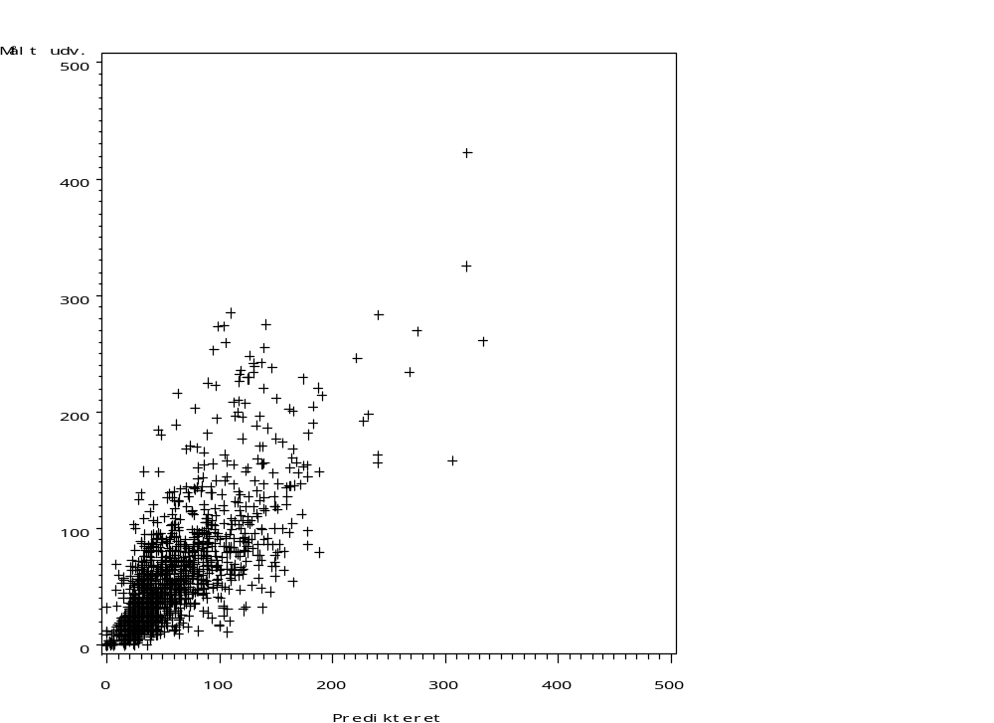

Figure 1. Plot of recorded leaching against leaching predicted by the model.

In figure 2 the effect of N has been shown for cereal followed by bare soil, cereal followed by winter cereal and cereal followed by a catch crop, rapeseed or undersown grass on a sandy and a clay soil. The calculation assumed that N level is identical to N spring + N fixed, that there are no other N allocations to the crop and that the precrop has been cereal/bare soil. On sandy and clay soils, drainage of, respectively, 515 and 394 mm has been used. It should be noted that the large effect of crop group ‘cereal with undersown grass/catch crop or followed by rapeseed’ at large values of N level have been estimated on the basis of results from fields with an undersown crop or cereal followed by rapeseed. Trials with actual catch crops have mainly been at low N levels.

In figure 3 the annual effect has been shown for the same crops and soil types assuming that N level and N spring + N fixated are both 160 kg N/ha, that there are no other N allocations to the crop and that the precrop was cereal/bare soil. The drainage used here were also, respectively, 515 and 394 mm for sandy and clay soils.

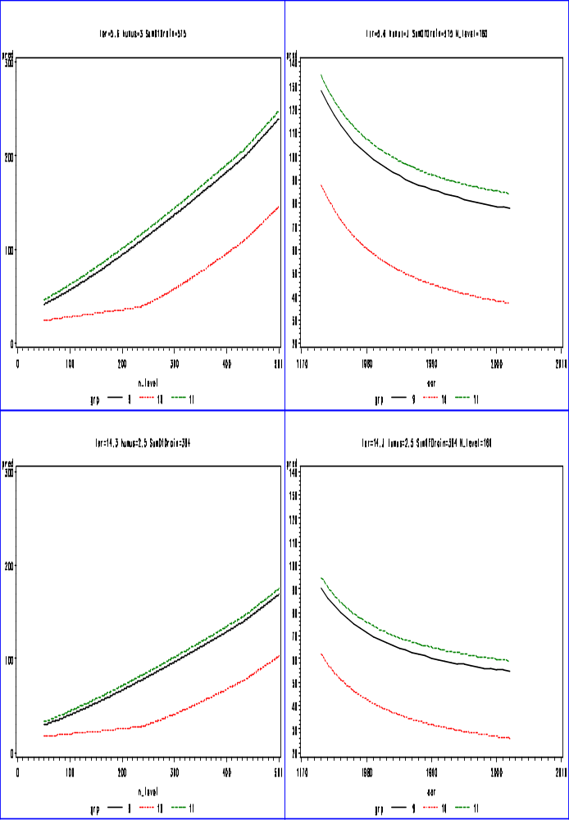
Figure 2. Response to nitrogen fertilization for three cereal crops (9=cereal followed by winter cereal, 10=cereal with undersown grass and cereal followed by a catch crop or rapeseed, 11=cereal followed by bare soil) and two soil types/drainages.
Figure 3. Response to changed technology (over years) for three cereal crops (9=cereal followed by winter cereal, 10=cereal with undersown grass and cereal followed by a catch crop or rapeseed, 11=cereal followed by bare soil) and two soil types/drainages.

Acknowledgements

The authors would like to thank Margit Schacht for translating this work from Danish to English.

References
Høgh-Jensen, H., Loges, R., Jørgensen, F. V., Jensen, E. S. & Vinther, F. P. (2004) An empirical model for quantification of symbiotic nitrogen fixation in grass-clover mixtures. Agricultural Systems 82, 181-194.

Larsen, S., Kristensen, K. 2007. Udvaskningsmodellen N-LES₃ – usikkerhed og validering. DJF rapport, Markbrug. 132 (in print)

Plauborg, F., Refsgaard, J.C., Henriksen, H.J., Blicher-Mathiesen, G., Kern-Hansen, C. 2002. Vandbalance på mark- og oplandsskala. DJF rapport, Markbrug. 70, 45 pp.

Simmelsgaard, S.E., Kristensen, K., Andersen, H.E., Grant, R., Jørgensen, J.O., Østergaard, H.S. 2000. Empirisk model til beregning af kvælstofudvaskning fra rodzonen. N-LES. Nitrate Leaching EStimator. DJF rapport, Markbrug. 32, 67 pp.

See http://www.dmu.dk/1_viden/2_publikationer/3_ovrige/rapporter/VMPII/Genberegning_af_modellen_NLES.pdf

